SOA Process and Method

Introduction
Service Oriented Architecture (SOA) is an architectural approach where business capability is encapsulated in reusable components called Services.
A Service represents a container of business tasks for the particular business capability in question, these tasks are called Service operations. For example a Customer Service will contain a set of functions in the Customer business capability such as retrieving the Customers accessibility details or modifying the Customers address.
In Lloyds the capabilities of a Service are realised by, for the most part, our existing applications.
Lloyds are using a SOA approach across a range of projects and programmes to deliver solutions. It is an architectural style and not the only approach available to a Solution Architect; however, using SOA is encouraged where the business capabilities being delivered by the project are common functions of a Bank and likely to be reused across a number of solutions in the future.

Service Architecture
Lloyds SOA standards are found in the Troux Enterprise Architecture Repository, as shown below. These provide guidance to Solution Architects on our Principles and Policies around SOA as well as many standards for Architects to follow, for example the Service Naming Standards and Service Versioning Standards.
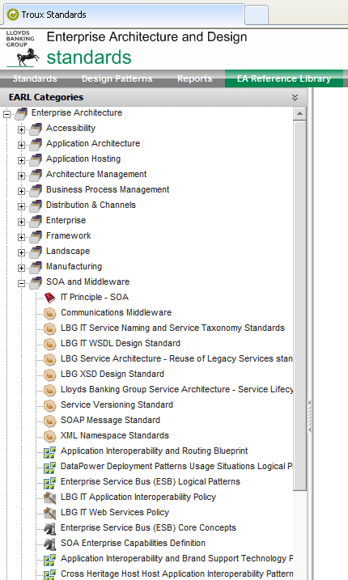

SOA Method
Lloyds employs a standard SOA method in keeping with IBM’s Rational Unified Process (RUP) and Service Oriented Modelling and Architecture (SOMA). This is a four stage process as below

Service Requirements
The initial phase of SOMA, called ‘Business Transformation Analysis’, is an analysis of the business in its entirety to create a Service Portfolio based on the vision for the Business. In this respect Lloyds differs from SOMA; this stage encompasses an analysis of the requirements of a project, breaking down these requirements into Business and System Use Cases.
This is primarily a function driven by the Business Analyst (BA) but with input from the Solution Architect (SA), the output is a documented set of requirements in Rational Requirements Composer.
This occurs during the Study phase of the project.
Lloyds have accelerated the creation of a Service Portfolio by purchasing IBM’s Banking Process and Service Model, a part of IBM’s Information Framework (IFW). This provides a UML model containing the main structural components of a Bank and their use a in a set of Services and Processes. This model is extensible and has been significantly added to by Lloyds over a number of years resulting in the Lloyds Common Service Model (LCSM).

Service Identification
The next stage of the SOA Method is to identify an initial set of required services and associated operations to meet the requirements of the business. There are three primary ways of achieving Service Identification
- Top down or ‘Domain Decomposition’ which focuses on the business starting from the business processes and use cases
- Bottom up or ‘Existing Asset Analysis’ where candidates are identified from an examination of existing applications and application interfaces
- Meet in the middle or ‘Goal Service Analysis’ where business requirements are matched to the existing IT capability that can be extended to meet the needs of the new goals, processes and Services
This function is primarily an action for the Solution Architect with some assistance from BA’s and Subject Matter Experts.

Top Down Service Identification
There are a number of approaches which can assist top down analysis. Functional analysis of the business requirements allows a Solution Architect to identify boundaries of the solution, for example where there may be a number of use cases on customer communications which can be treated as one domain and potentially a service with a number of operations. Functional analysis can also lead to a set of IT Sub systems that provide this functionality allowing the architect to identify the applications involved in his solutions and potentially existing services which may be reused in certain domains.
The second approach to top down analysis is process decomposition. This may require the architect to further breakdown the business use cases, for example an ‘Open Account’ use case would breakdown into a series of steps in a process (e.g. gather customer details, record customer details, validate customer credit history etc) and these steps may lead in turn to the identification of service operations. In some cases a business process may already be provided, each process is a series of tasks that are performed by a human or system actor. The tasks performed by systems can often be equated to a series of identified service operations.
The final approach is term variability analysis, this approach starts with identifying the key data elements in the requirements, for example Customer, and then determining the change or variable elements of these objects as part of the design, for example product holdings. The variable elements of a common object within the solution can then lead to candidate service operations such as modify Customer Product Holdings.
All of these elements of top down service identification are greatly assisted by the presence of a Service Model. Lloyds utilises a number of these models held in the reusable assets of RSA, the primary one being the Lloyds Common Service Model (LCSM).

An Introduction to LCSM
The Lloyds Common Services Model is actually composed of 3 models, the Analysis Process Model (APM), Business Object Model (BOM) and Interface Design Model (IDM); as shown below
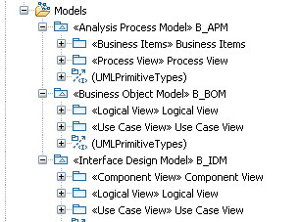
Whilst the APM is not used within Lloyds (as the organisation has created its own Business Process Framework, albeit with occasional reference to the APM) it is a useful asset when identifying Services as it contains a set of processes with corresponding workflow or Use Case charts, a simplified view of the Use Case for ‘Retrieve Involved Party Details’ is shown below
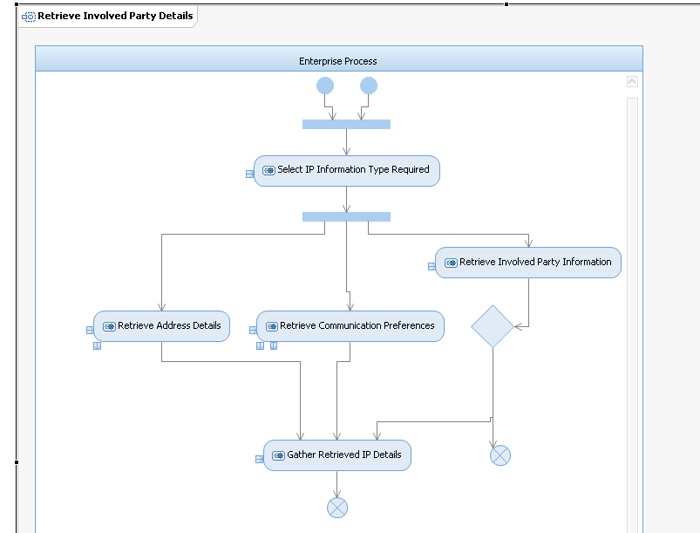
Business Object Model
The BOM is used to analyse requirements and identify the Service operations that satisfy these. Requirements effectively come in two forms, data and functional. The logical view within the BOM effectively represents data within LCSM as a set of classes.
Data Viewpoint
The logical view is structured into a series or packages, these packages are purely structural, grouping sets of related classes as shown below.
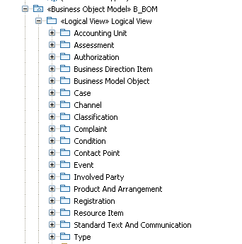
The packages are:
- Accounting Unit - models repositories used to monitor both monetary and non-monetary standings. Effectively the monetary aspects of an account such as balance and postings.
- Assessment - models estimation of states that are of interest to Lloyds. For example a customer rating or property valuation.
- Authorization - models Involved Party access to financial services Arrangements and defines how financial services products behave across various channels. For example access tokens used by a party to access an account.
- Business Direction Item - models the expression of an involved party's intent with regard to the manner and environments in which it wishes to carry out its business. For example campaigns plan.
- Business Model Object - models responsibilities, attributes and associations that are common to all the key types in the model. This is the top level object in the model from which other objects inherit. All types of identifiers are modelled from the BMO.
- Channel - models the conceptual conduits through which Lloyds communicates to the outside world in the course of its business.
- Classification - models dynamic categorisation of the objects in the model by defining sets of objects, for example category or Market Segment.
- Condition - models requirements that pertain to how the business of a financial institution is conducted, including prerequisite or qualification criteria, restrictions and limits. Condition covers such items as rules, fees and rates.
- Contact Point - models addresses in a general sense as well as preferences of how parties want to be contacted. For example any accessibility details of the customer (e.g. Braille)
- Event - models spontaneous and planned occurrences within the domain Lloyds. For example a payment instruction (scheduled or planned event) or a transfer.
- Involved Party - models parties independently of their involvement with Lloyds. An Involved Party can be an individually or an organisation. Involved parties themselves can play different roles and may hold a number of roles at once, for example an Individual can be both an employee and a customer of Lloyds. This package also holds an Involved Party hierarchy showing the various types of IP as well Organisation and Organisation subtypes (Company, Corporation; branch, call centre)
- Product and Arrangement - models financial services products and defines how financial services arrangements are created and maintained based on the definition of a product. A product represents goods and services sold by Lloyds; it has a lifecycle and a range of subtypes such as Fixed Term Deposit or Credit Facility. An Arrangement represents the actual agreement between the Bank and an Involved Party and is as varied as a Deposit Arrangement to an Employee contract. A Product Arrangement is created when an Involved Party purchases a Product and has a range of subtypes in the model, for example Investment Arrangement or Term Loan Arrangement.
- Registration - models different types of official registrations and the role of each of these types of registration in the financial services industry. For example VAT Registration or Marriage Registration.
- Resource Item - models physical objects and other items of interest to Lloyds TSB Group. For example cheque book, statement or a residential property
- Standard Text and Communication - models templates that can be used for mass-generating documents, as well communications that are inbound to or outbound from Lloyds. This contains documents, both electronic and physical, and other communication types such as SMS.
- Type – models supporting objects relevant to the model, such as enumerations, lifecycle states, and primitive data types such as date or currency amount.
- Case – This package has been added by Lloyds and provides the ability to track, throughout its lifecycle, significant, customer related processes across the various channels of the organisation (e.g. Account Transfer or a Fraud investigation).
- Complaint – This package has been added by Lloyds and records the all details related to a customer complaint, along with the various actions taken, and how it is resolved.
- Quotation and Proposal – This package has been added by Lloyds and holds different forms of quotations provided by the Bank to the Involved Party. Illustrations are in this package as a type of non-binding quotation. A Proposal is also modelled in this package, this being a formal offer from the Bank to the Involved Party, for example a Proposed Arrangement or Credit Proposal.
Each package therefore contains a set of related classes and diagrams. Each UML class represents the attributes and methods applicable to the class, as below for an Individual
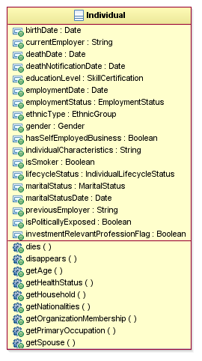
Functional Viewpoint
The other view provided by the BOM is a set of Service use cases. These match to a set of Business Service operations providing business functions and can be used to identify the projects set of candidate services derived from the requirements. The use cases are divided into structural (fine grained) and transactional (coarse grained) operations. For the most part Lloyds use transactional services.
Again these are grouped into packages of related use cases. The package often represents a coarse grained service with each related use case equating to an operation on that Service, as in the example below which illustrates the Arrangement Negotiation Service (a package) and the activateProductArrangement operation (a use case)
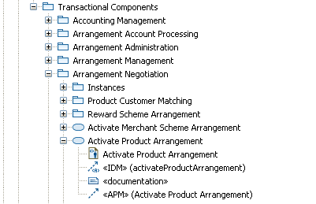
Each use case has a UML use case diagram associated with it, as illustrated for retrieveArrangementTransactionHistory below
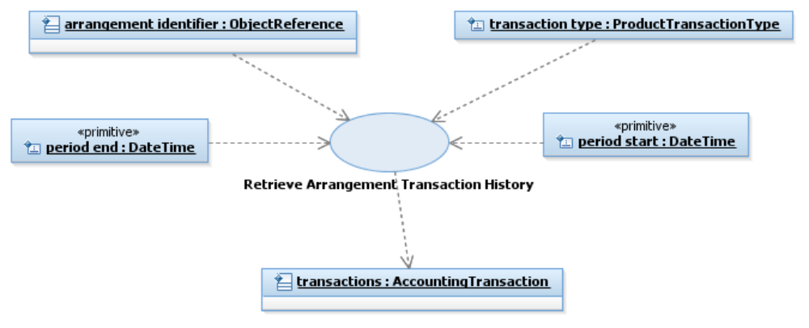
Each Transactional Use Case also has a list of relationships linking it to the Process Model and Interface model as below
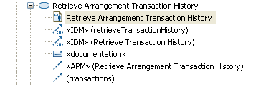
These use cases, traced from business requirements, can therefore be used to navigate to the actual Service (interface) and operation as part of Service Identification.
The first relationship (in camel case) can be used to navigate to the operation in the IDM whereas the second relationship can be used to navigate to the use case in the IDM (see next section)
Interface Design Model (IDM)
IDM is divided into 3 views, these are the component, logical and use case views. In general the view widely used in the IDM is the logical view. The logical view is broken into structural and transactional components and much the same package structure as seen previously in the BOM; however, the UML classes in the IDM represent Interfaces and the Operations on those Interfaces. These are the reusable interfaces used in the Application Architecture of an Architecture Description as seen in Compass here
http://hbos.intranet.local/gito/adf/COMPASS2/EAD%20Industrialised%20Design%20Pages/Enterprise%20Services%20and%20LCSM.aspx

Governance and the Service Repository
The LBG Service Lifecycle is shown below
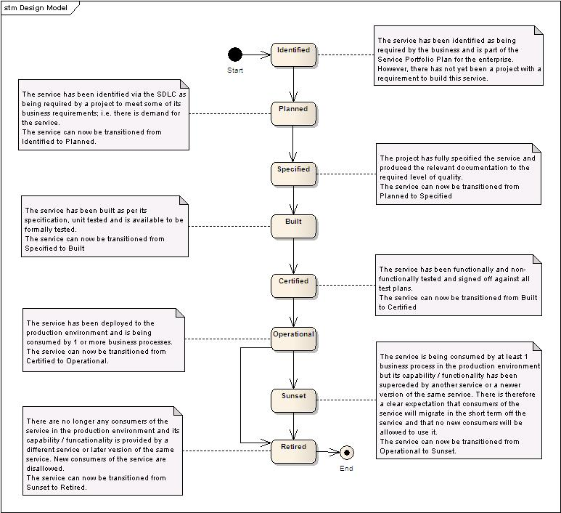
This lifecycle is governed within the Service Repository built on HP Systinet technology. As the Service moves through the lifecycle tasks have to be completed and the Service submitted for approval to transition to the next state.
In terms of the SOA Method, during the ‘Service Identification’ phase a candidate Service moves into the ‘Planned’ state within the lifecycle once approved. This approval is through the Service Governance Board (SGB) with the details of the candidate Service being submitted to SGB on a ‘Service Concept Document’.
The main purpose of governance at this stage is to ensure the correct Service and Operation has been identified during the design based on the requirements and that any opportunity to reuse existing Services has been identified.
<include stage governance from lifecycle document>

Service Specification
The next stage of the SOA Method is to create the Service Specification. The specification provides both functional and non-functional characteristics of the Service instance acting as the contract between the consumer and provider.
The specification defines the operations of the Service with parameters. In Lloyds the terms Service and operation are often used interchangeably and Service Designs are produced for each operation of the Service. A Service Design document contains
- A description of the function of the operation describing it’s use and any behavioural or structural constraints
- The contract or signature of the operation (parameters)
- Any modelling elements used with any changes highlighted
- At a high level the realisation of the Service through interactions between applications (this is not strictly necessary as the implementation is separate to the contract but does aid the consumers understanding)
- The request and response messages for the operation
There are three main approaches to Service Specification

Service Design
In this approach the designer is concerned primarily with exposing the business functionality expected from the requirements initially expressed. This approach lends itself well to the kind of use case analysis and top down design described earlier as it is driven by the needs of the consumer, often a Business Process. Message design is secondary here and driven from the Service Design

Message Design
In certain cases messages may already be well documented, for example a scheme defined message model such as ISO20022 or when Services have been identified from existing assets, that is bottom up identification.

Collaboration Design
This approach is more process or composition centred and focuses on creation of a coarse grained composite Service from existing Services in the portfolio. These coarse grained Services are likely to be less reusable than their finer grained composite parts

Governance
The specification will be created by a Service Designer, once complete this specification must also be approved by the Service Governance Board, moving the Service to the next lifecycle stage of ‘Specified’.
<include stage governance from lifecycle document>
At this stage SGB is looking to ensure Lloyds SOA Principles have been followed by considering the following
- Ensure the Service is business aligned. It must be traceable back to a defined business goal or task. Care is needed when designing fine grained Service operations often derived from application interfaces that this is the case
- Ensure the business is willing to fund the delivery of this Service and the resulting Service will be reusable, potentially resulting in additional cost to scale or amend
- The Service is composable and self contained, that is it fulfils it’s own function through it’s independent deployment but may also participate in a composite service to fulfil a different business goal
- The Service is abstracted from its technical implementation with no implementation details leaked into the contract.
- The Service is discoverable, that is named and described appropriately for its business function, has implementation neutral WSDL and is registered in the SOA Repository. On discovering the Service a consumer must be able to have all the information required to understand and use the Service
- Is the Service implementation technically feasible

Service Realisation
Service Realisation is an implementation activity and performed by the various ADM platform teams. It includes the next three lifecycles of the Service
- Built. Code is designed, developed and deployed into early test environments. Initial testing is performed
- Certified. Later stages of testing are performed once the individual elements of the Service have been integrated into an executable system
- Operational. The Service is fully tested and deployed to production environments
Not all Services are, of course, built from internally developed components and Services may be realised from packaged applications, externally hosted applications or schemes or from simply integrating together existing application logic.
The components that realise a Service are identified during the Solution Design and elaborated on during Cross Platform Design.
A key component in realising the Service Specification is the Enterprise Service Bus on which are built any mediations required to build the Service, often from a mix of disparate applications as described above.

